**Kolbe Catholic College**

**Year 8 Science**

**Term 2: Chemistry**

***Year 8 Term 2 Revision – Formative Assessment***

1. **Complete** the table below to **summarise** the properties of solids, liquids and gases

|  |  |  |  |
| --- | --- | --- | --- |
| **PROPERTY** | **SOLIDS** | **LIQUIDS** | **GASES** |
| Forces between particles (relative terms) |  |  |  |
| Position of particles |  |  |  |
| Movement of particles |  |  |  |
| Shape |  |  |  |
| Volume |  |  |  |
| Diagram to show how particles are arranged |  |  |  |

1. **Explain** the difference between physical and chemical changes, and give two examples of each.

|  |
| --- |
|  |
|  |
|  |
|  |

**3. Draw** arrows on, and **label** the diagram below to show where the following changes

take place between the states of matter: **Freezing, melting, condensation, evaporation, sublimation**

SOLID LIQUID

GAS

1. **Define** the words condensation, evaporation, sublimation, melting, freezing.

|  |
| --- |
|  |
|  |
|  |
|  |
|  |

1. For each of the following, **identify (name)** the change of state described, and **explain** what happens to the particles when:
2. Liquid changes to gas

|  |
| --- |
|  |
|  |
|  |
|  |

1. Solid changes to liquid
2. Gas changes to liquid
3. Liquid changes to solid
4. **List** the first 20 elements of the periodic table. **Write** the name and chemical symbol for each.

|  |
| --- |
|  |
|  |
|  |
|  |

1. **Define** the terms ATOM, ELEMENT, COMPOUND, MIXTURE, MOLECULE and **list** two examples of each.
2. Using the following symbols: A = , B = , and C = , **draw** a diagram to represent:

**a)** element C as a gas

**b)** an atom of element B

**c)** a molecule of A and B

**d)** element C as a solid

**e)** a compound of A and C

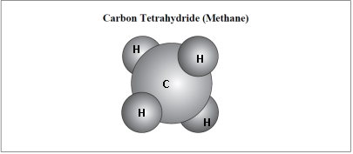

1. **Write** the formula for the molecule shown on the right:
2. **Identify** the general location of METALS and NON-METALS on the periodic table, and list 3

examples of each type.

|  |
| --- |
|  |
|  |

1. Look at the two graphs shown below showing changes of state for water:

**Graph 1: Graph 2:**

[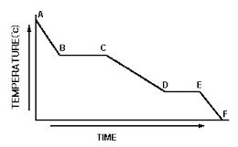](https://www.google.com.au/url?sa=i&rct=j&q=&esrc=s&source=images&cd=&cad=rja&uact=8&ved=0ahUKEwiR_cWh-bbSAhUEupQKHSVjDfoQjRwIBw&url=https://www.smashwords.com/extreader/read/10442/96/practice-makes-perfect-in-chemistry-the-physical-behavior-of-matter-with-answers&bvm=bv.148441817,d.cGw&psig=AFQjCNGW25i6qL0G2vSqyp_sZ90OMxuNig&ust=1488514051543047)[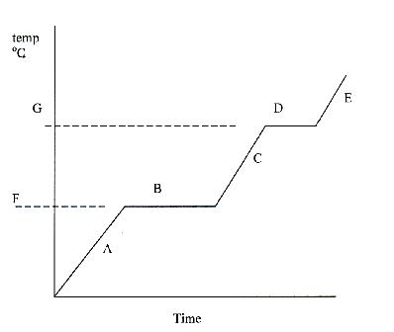](http://www.google.com.au/url?sa=i&rct=j&q=&esrc=s&source=images&cd=&ved=0ahUKEwiU4KrL-LbSAhVIW5QKHauwCCcQjRwIBw&url=http://www.proprofs.com/quiz-school/story.php?title%3Dthermochemistry-heat-absorbed-specific-capacity-change-in-states&psig=AFQjCNFfN_5AFb4GHrxE7tEh4cBsvgH70Q&ust=1488513745558536)

E

B

D

C

A

A

L

J

K

I

H

F

1. **Identify** which graph shows water being heated, and which graph shows it being cooled.

|  |
| --- |
|  |

1. **Label** the points marked on each graph with the name of the process occurring at each point.

|  |
| --- |
|  |

1. **List** the main points in the particle model of matter.

|  |
| --- |
|  |
|  |
|  |
|  |
|  |

1. Use the ideas from the particle model to **explain**:

**a.** why drops of melted candle wax run down the sides of a burning candle, then form a solid part way down the candle.

|  |
| --- |
|  |
|  |
|  |

**b.** why droplets form on the side of a glass with a cold drink in it

|  |
| --- |
|  |
|  |

**14.** Use the table below to answer the questions that follow:

**a. List** the elements that make up:

|  |  |
| --- | --- |
| COMPOUND | FORMULA |
| Alcohol  Ammonia  Cane sugar  Carbon dioxide  Hydrochloric acid  Iron oxide  Sodium chloride  Water | C2H5OH  NH3  C12H22O11  CO2  HCl  Fe2O3  NaCl  H2O |

i. Ammonia

ii. Cane Sugar

**b. State** which compound would have the largest molecules.

**c. State** which compounds contain Carbon.

**d.** **State** the number of oxygen atoms in Iron oxide.

**15.** **Identify** which picture below best represents:

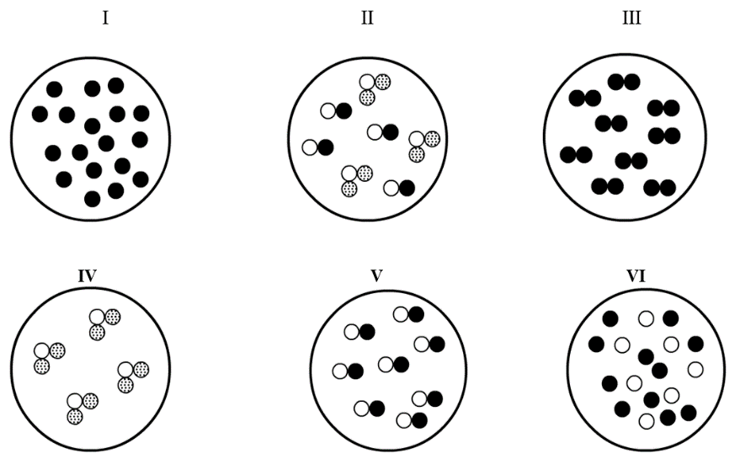**a)** atoms of an element

**d)** molecules of a compound containing three atoms

**b)** molecules of an element

**e)** a mixture of elements

**c)** molecules of a compound made of 2 elements

**f)** a mixture of compounds

**16. List** some properties of a material that would be suitable for making a ski jacket. **Identify** which would be the *two most important* properties of the material, and **justify** why you think these are the most important properties needed.

|  |
| --- |
|  |
|  |
|  |
|  |
|  |
|  |
|  |